CANBERRA & DISTRICT RABBIT CLUB INC.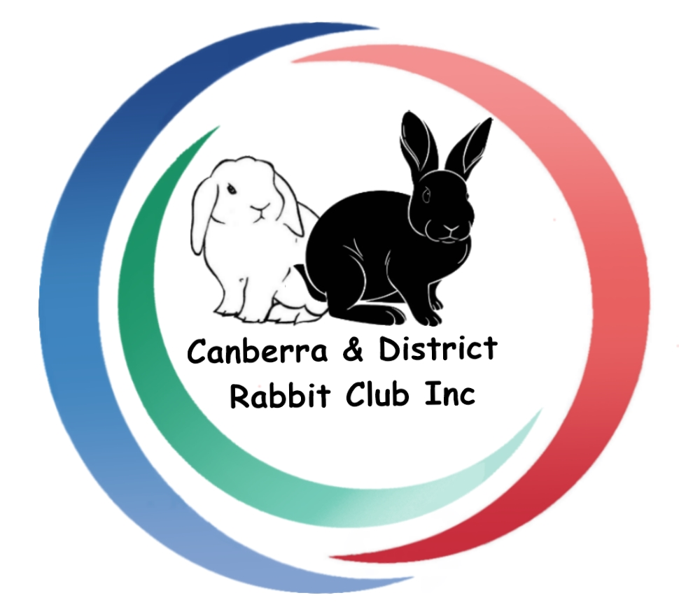

Membership/Renewal Application
(Please use block letters)
(Updated Nov 2020, supersedes previous forms)

Name…………………………………………………………………………………………...

Address….……………………………………………………………………………………...

………………………………………………………………...……… Postcode….………….

Phone………………………Email…………….…………………………………….………...

Please tick your preference for receiving newsletters:

⌧Please send to email address
⌧Please post hard copy (add an extra $5 to your membership fee)

Website………………………………………………………………………….……………............................ Stud prefix……………………………………………………………………………………............................

I/we would like to be registered as a breeder of the following rabbits:

.............................................................................................................................................................................. ..............................................................................................................................................................................

⌧ Please tick if you want these details on the CDRC website Breeders Directory
⌧Please tick if you consent to photos being put on social media or in newsletters

I hereby apply for membership of the Canberra & District Rabbit Club Inc. for one year. If my application is accepted, I agree to be bound by the rules of the club for the period of my membership. Memberships due July each year.

Signature……………………………………………………………………Date………………………………………...

Annual fee for single members $25.00 Annual fee for families $30.00

Post (cheque or money order) with application form to Crystal O’Hara: PO Box 958, Goulburn NSW 2580. Cheques/money orders payable to Canberra Rabbit Club Inc
Payments may also be made by electronic bank transfer to club account: Westpac BSB 032636, Account no. 133235.
Please send an e-mail to Crystal (canberrarabbitclubsecretary@gmail.com) stating what it was for and the amount deposited.

