Beauty, Art and the Western Tradition
Derek Allan, Australian National University
(This text includes most of the PowerPoint images used with the paper.)
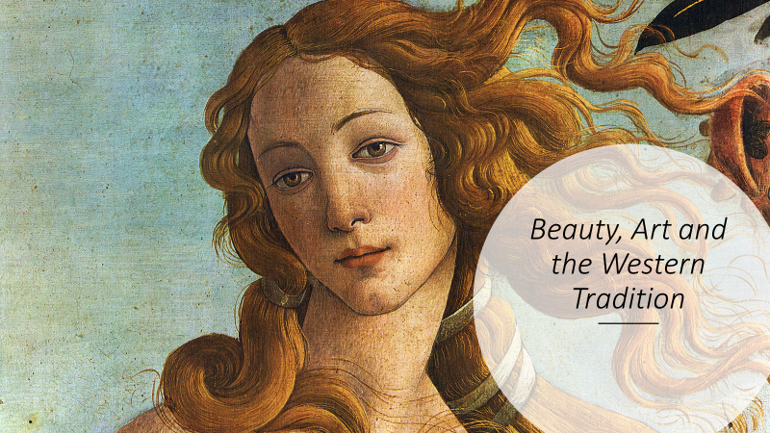

The phrase “Western tradition” has proved somewhat controversial of late but it’s essential to my remarks today because the developments I’d like to examine have been specific to European culture, and more broadly to the tradition we loosely describe as Western. Today, of course, there’s hardly a corner of the earth where the influence of that tradition has not penetrated to a greater or lesser degree, and the term “Western” has perhaps become somewhat inadequate; but the pervasiveness of this influence, whatever we choose to call it, has, I think, only increased the need to examine its key aspects, and my paper today focuses on one of these.
The aspect of the Western tradition I’d like to consider is the intriguing question of the idea of beauty as it relates to art. Why intriguing? Well, first, because this idea, in the specific sense I’ll discuss, has been peculiar to Western culture, and this fact is not always recognised, even by modern philosophers of art who make use of it; second, because, for reasons I’ll outline, the idea of art as beauty, which exerted an exceptionally powerful influence on Western culture for some five centuries, has run its course and is now a spent force; and third, because, despite the demise of this idea, its ghost still haunts us, and, in so doing, sows unnecessary confusion, and often places a barrier between us and the world of art in which we now live.
These are strong claims, and ones that might cause some people, including many philosophers of art, to raise a sceptical eyebrow, so let me explain myself in a systematic way, setting out my arguments step by step.
But first, a preliminary point. It’s probably true to say that the languages of all cultures, past and present, have included terms that roughly equate to the English term “beauty”, just as they have doubtless included words roughly equivalent to, say, ugly, brave, dangerous, false, despicable, and so on. So, nothing in what I’ll say today is intended to suggest that Western culture has now, or ever has had, a monopoly on the notion of beauty in ordinary, everyday senses of the term. All cultures, I assume, have been perfectly capable of expressing ideas roughly equivalent to “beautiful scene”, “beautiful woman”, “beautiful day”, and so on. So, the issue I’ll discuss has nothing to do with the idea of beauty in everyday usages such as these. My concern is a particular idea of beauty – or more accurately, a particular idea for which the word “beauty” came to be used as the conventional label.
I’m going to begin my explanation with a brief excursus into the history of European art, focusing on certain decisive events, and I’ll concentrate principally on visual art because it allows me to illustrate my arguments more easily. I should mention also that my thinking in this area has been strongly influenced by the French art theorist André Malraux whom I’ll quote now and then. Malraux is one of the rare modern thinkers whose theory of art is closely related to key events in the history of art, and my argument today has important historical components.
I want to begin in pre-Renaissance times. As we know, the history of European civilization from Constantine until the Renaissance was in large measure a story of the spread and consolidation of the Christian religion, even if that process sometimes involved doctrinal disagreements and even schisms. The central importance of religion over this period is, as we’d expect, reflected in the painting and sculpture of the times which is dominated by religious subjects. Here are two representative examples: the austere, commanding figure of the Christ in Majesty at Moissac in France, sculpted around 1100, and the equally impressive image of the Madonna and Child in the Torcello Cathedral in Venice created a little earlier. Both works are now widely seen as masterpieces, but they also suggest something important about the Christian faith of the times. This faith was strongly dualistic in the sense that its
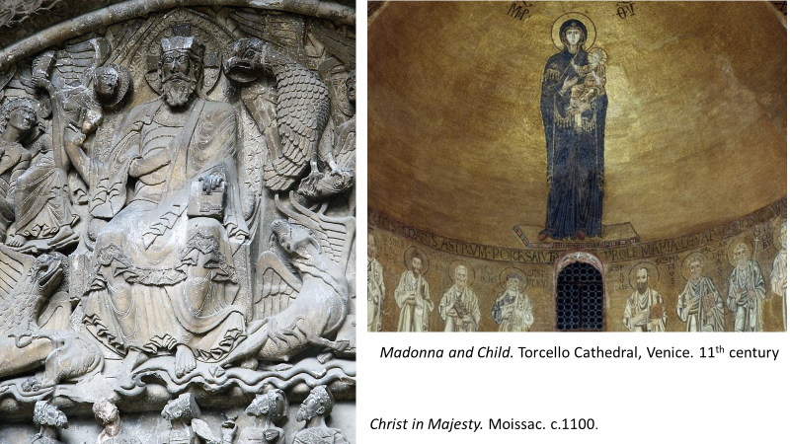
God was a wholly supramundane being, essentially beyond the reach of human understanding. God was love, and humanity had access to Him through love, but this was sacred love and the ultimate mystery of God’s being remained inviolate. The Revelation brought communion with the mystery but not an elucidation of it.
In Italy, in the fourteenth century, however, a major change took place. There was a gradual rapprochement between man and God and one notices this immediately if one compares a painting by Giotto, dating from the early fourteenth century, with the Madonna and Child in Torcello we’ve just considered (see next page). Both are powerful images but Giotto’s world, while still retaining the solemnity of a sacred realm, has taken on a human aspect which is absent in the Torcello mosaic. André Malraux describes the situation this way:
[Giotto] discovered a power of painting previously unknown in Christian art: the power of locating without sacrilege a sacred scene in a world resembling that of everyday life … For the first time, sacred scenes related no less to the world of God’s creatures than to the world of God.
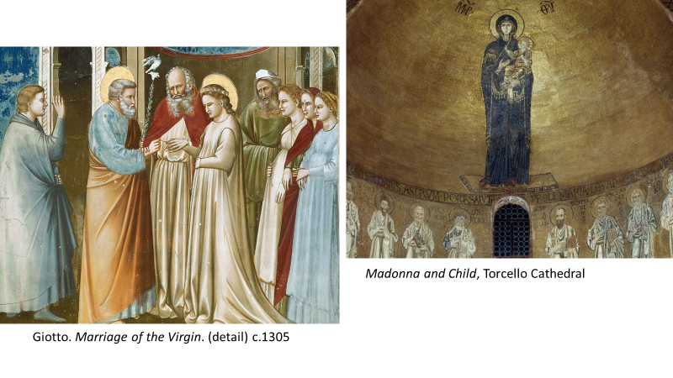
This was a turning-point in European art, with major consequences for the ensuing centuries. By depicting a world which “related no less to the world of God’s creatures than to the world of God”, Giotto had brought the divine onto a plane nearer to man, and in doing so opened the door to a world in which humanity itself could share in qualities of the divine. In effect, this was the beginning of a new vision of transcendence rivalling that of religion. “It was not that religious feelings had disappeared”, Malraux writes,
but that these were complemented now by the discovery of an imaginary realm conveyed to the spectator by a power of the artist, distinct from his power of representing scenes from Scripture in that it no longer calls forth veneration, but admiration.
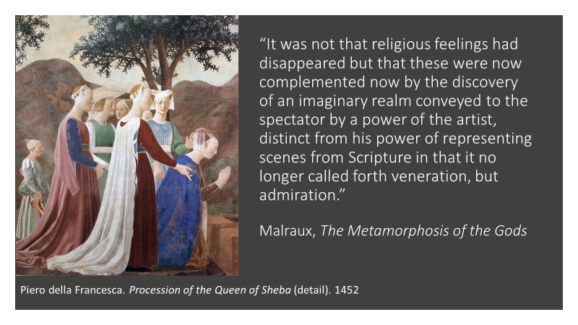
In the course of the fifteenth century, this new vision of transcendence emerged into the full light of day and in exploring the newly-discovered realm of the imaginary, painting and sculpture also began to call on the mythology of Antiquity whose heroes, gods and goddesses seemed to offer a repertoire of exalted deeds befitting such a realm. For Botticelli, especially in his non-religious works, it was no longer just a question, as it had been for Giotto, of “locating without sacrilege a sacred scene in a world resembling that of everyday life” but now of creating a transfigured earthly realm that openly rivalled that of the sacred. Thus, Malraux writes, the admiration inspired by a painting such as the Primavera,
like that inspired by Antiquity, and which Antiquity now legitimised, is addressed to a demiurge which, for the first time, rivals the Christian demiurge, because for the first time it gives exalted expression to a fiction drawn from the realms of the profane.
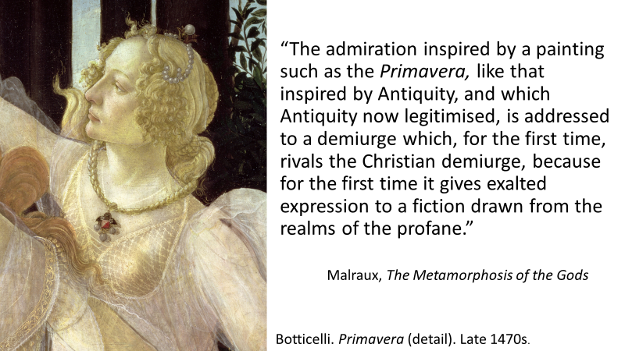

In short, a revolutionary development had taken place. Source of a “nobler” world – a world of harmony and beauty, peopled by men and women seemingly touched by a spark of the divine – the painted image or the sculpted figure was no longer an object of veneration, as it had been in Byzantium and mediaeval Europe, but of admiration – an admiration dependent on the achievement of the artist and on no other source. Botticelli’s successors include all the major figures of Western art for the next four centuries – figures such as Raphael, Michelangelo, Titian, Poussin, Tiepolo, Watteau and even Delacroix in the nineteenth century; and common to them all, as these three examples illustrate, (see next page) is the pursuit of a transfigured world of harmony and beauty. It is not necessarily an idyllic world. Sometimes, as in the Titian here, it depicts calamity and tragedy, but it is always a transfigured world – not a mere imitation of appearances but an exalted world pervaded by a sense of nobility, harmony and beauty. Art historians have often claimed that the art born with the Renaissance was essentially the pursuit of a greater naturalism or realism but this, in my view, is a mistake. It is obviously true that there is an increased naturalism in Renaissance and post-Renaissance works but this is an ancillary feature springing from the artist’s need to establish that the transfigured realm in question is, after all, a human realm, and a descendant of Giotto’s world which “related no less to the world of God’s creatures than to the world of God”. As Malraux points out, over time Europe began to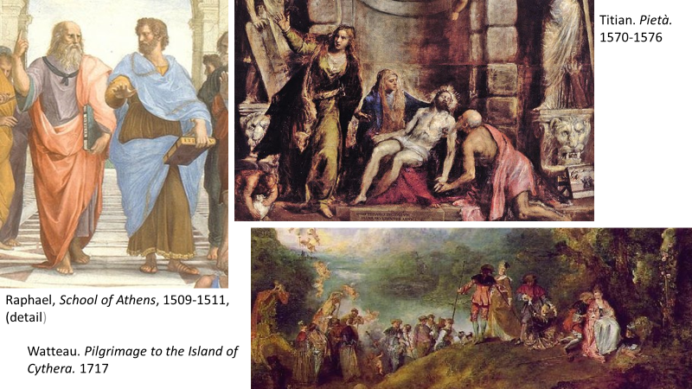 take it for granted “that one of painting’s supreme prerogatives was the creation of the semblance of reality”, but in fact this was not the principal aim because, although it set out to master a certain range of visual experience, art was always seen as something different in kind from the world of appearances, and
what was now asked of art was less an imitation of reality than the illusion of an idealised world. While attaching so much importance to imitative technique, and to making figures seem real, this art was in no sense realistic; rather it aspired to be the most persuasive expression of a fiction – of a harmonious imaginary world.
Sir Philip Sidney summed up the point in a well-known statement in his Apology for Poetry written in 1580, which I’ll illustrate by a work by Veronese painted coincidentally in the same year: Sidney wrote: “Nature never set forth the earth in so rich tapestry as divers poets have done. Her world is brazen, and the poets only deliver a golden”. And what was true of poetry was also true of visual art. The ambition of the post-Renaissance painter or sculptor was not simply to better mimic the world of appearances – Nature’s world of brass – but to evoke a vision of transcendence whose fundamental inspiration, whether depicting religious scenes or not, no longer stemmed from religious faith but from an imagined “golden” world in which humanity itself was touched by a spark of the divine.
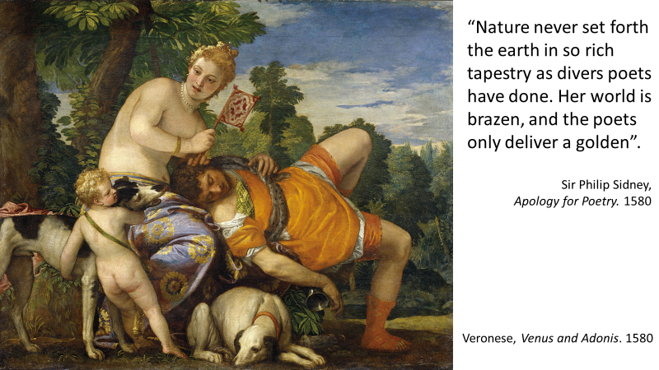

I have one more episode to recount in my very abridged history of European art, but before I do, I’d like to make one or two broader remarks about what I’ve said so far. The Renaissance, as we’ve seen, saw the emergence of a form of art quite different from the religious works that had preceded it. In fact, the very term “art”, and the special prestige Europe attached to it, owes its emergence to the Renaissance because “art”, or “fine art” was the term that came to signify the new golden world that had come into being. There now existed in Europe something called “art” which had never existed before – anywhere or at any time. The word “art” had existed in Europe before, but it had never had this meaning. And the fundamental inspiration, the central aim, of this new phenomenon called “art” was the creation of a particular kind of harmonious, imaginary world which, as time went by, was increasingly encapsulated by the single word “beauty”. Michelangelo, a rare case of a visual artist who was also a poet, summed up these beliefs in one of his sonnets: “Beauteous art”, he wrote, “brought with us from heaven, will conquer nature: – so divine a power belongs to him who strives with every nerve.” And by the eighteenth century, when Enlightenment philosophers such as Hume and Kant were laying the foundations of a philosophical aesthetics, this thinking had become so widespread that it was simply taken for granted. Art 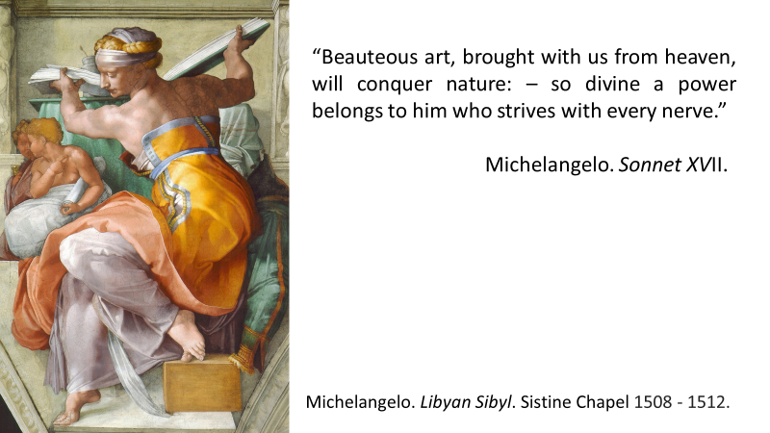was art because it embodied beauty; taste – a notion dear to the eighteenth century – was taste because it was the capacity to respond to beauty; the aesthetic pleasure that art was said to evoke was the form of pleasure stimulated by beauty; and art was also said to be timeless – eternal – because it possessed the divine quality of beauty. But beauty in the context of art, we must always remember, designated a particular kind of beauty. Byzantine mosaics (see next page) were not considered beautiful – in fact Vasari in the sixteenth century described them as clumsy, barbaric and grotesque; and mediaeval sculpture, likewise, was not beautiful, and much of it, as we know, was plastered over or destroyed. And of course, any suggestion that “beauteous art”, to borrow Michelangelo’s term, might include a Buddhist statue, a Chinese painting, a pre-Columbian figurine, or an African carving would have been laughed out of court. Art was a special kind of transcendent, golden world – the kind pursued by artists such as Michelangelo, Raphael, Leonardo, Titian, Poussin, Rubens and others in this same tradition; and well into the nineteenth century, painting or sculpture that lacked this attribute simply did not count.
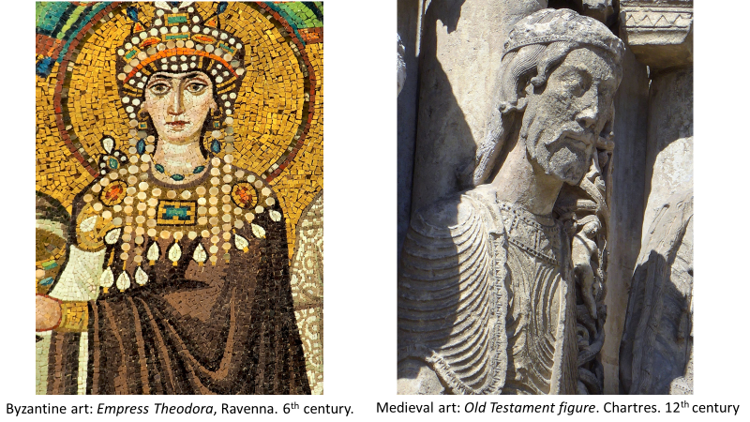
But let me turn now to the final chapter in my very brief history and in so doing bring it up to date – that is, to the period we call modern and contemporary art.
The Enlightenment has been blamed for many things, perhaps too many things, but something for which it is certainly largely responsible is the birth of what, for brevity, I shall call modern art. The effects were a little slow in coming because modern art was not born until the 1860s, sparked above all by Manet’s painting Olympia, painted in 1863 and first exhibited two years later. In what way was the Enlightenment a factor here? Quite simply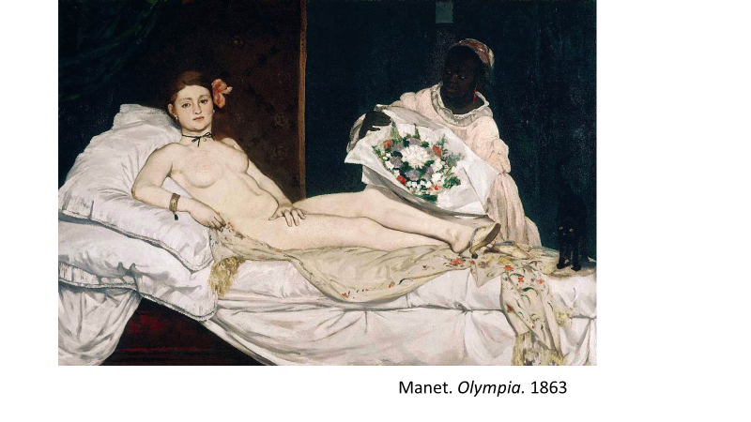 through its powerful and relentless assaults on religion, and its insistence, motivated by the triumphs of science, that the path to truth lay solely through the empirical, observable fact. This new understanding of the world progressively undermined any sense of transcendence – any sense of “another world” – including the special sense of a golden world on which art until then had depended. The “illusion of an idealised world” to borrow Malraux’s phrase – had been dealt a lethal blow, along with the gods, goddess, saints, heroes and heroines that had so often provided the subject matter of that world. Manet’s painting, as is well known, was ridiculed and reviled when first exhibited, the most frequent reproach, which I think rather surprises us today, being that it was ugly. To quote just a few of the contemporary reactions, Olympia was the embodiment of “perfect ugliness”, and “a sort of female gorilla”; her body had the “livid tint of a cadaver”; she was “a sort of monkey”, she was “incomprehensible”, and “never”, wrote one reviewer “has anything so strange been hung on the walls of an art exhibition”. Seen in context, however, this sense of shock should 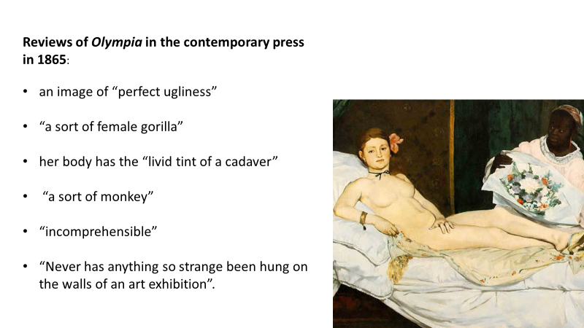not entirely surprise us. Olympia was a turning point in European art because it signalled nothing less than the death of the art of beauty that had ruled unchallenged since the Renaissance; and this event – “revolution” would be a better word – can be illustrated by juxtaposing Olympia with Titian’s celebrated Venus d’Urbino, painted some three centuries earlier, to which it quite deliberately refers. Olympia, writes Malraux, is “the Venus d’Urbino minus what the latter signifies” – by which he means that Manet gave birth to a new form of 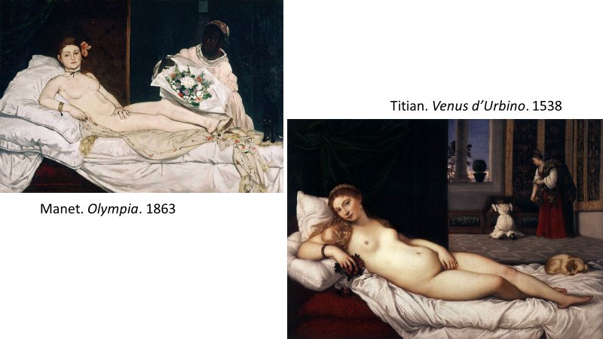art that no longer aspired to create a golden world – that no longer pursued the harmonious imaginary world of Raphael, Titian, Poussin, Rubens and so many others. Which immediately explains why so many of those who first saw Olympia judged it to be ugly and incomprehensible. It was ugly because it was no longer aspired to create a transfigured world of harmony and beauty; and it was incomprehensible because that, after all, was what art was, and without that aspiration, there could be no art. For contemporary audiences, in other words, Olympia meant that art itself had been abandoned, and “a sort of female gorilla” had taken its place.
What had Manet substituted for the art of beauty? What new form of art did Olympia inaugurate? As I’ve suggested – and many commentators would agree – Manet had given birth to what we now call “modern art” – the form of art we’ve witnessed for the past century and a half which includes names such as Cézanne, Van Gogh, Chagall, Picasso, together with a host of more recent names we sometimes categorise, rather oddly I think, as “contemporary art”. But what is this “modern art”? I don’t wish to enter into this question in any detail because my topic today concerns beauty and the Western tradition, and modern art, I’m arguing, signals the end – the demise – of that tradition. I will, simply say this: By the nineteenth century, as I’ve said, the West was ceasing to believe in anything involving non-empirical, “transcendent” worlds. But although this avenue was closing, art’s basic capacity to create another world – the capacity it had until now placed in the service of beauty – was still intact, and it was this that modern art fell back on. For the first time, André Malraux writes, painting “discovers the autonomy of painting” and is no longer in the service of anything beyond itself. Left to its own devices in an increasingly agnostic culture, art post-Manet relies on its own powers and nothing more.
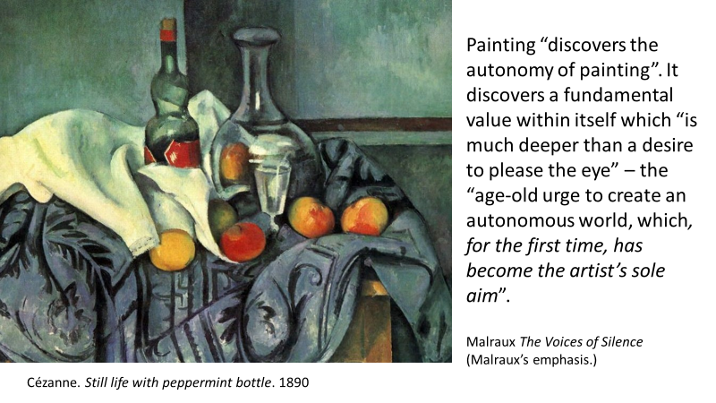
The idea is not easy to grasp on first encounter and, as I say, I don’t wish to dwell on it at any length, but the basic point I wish to make is that the death of beauty as an ideal did not, as it turned out, mean the death of art, because art was reborn in another form via the artist’s fundamental capacity to create another world – a world now independent of any value outside itself. As it happened, the art of beauty – if I can use that shorthand description – did not die overnight and the nineteenth century witnessed what can only be described as its slow death agony. There was still a handful of major artists working within the tradition – such as Delacroix in France and Turner in England – but the dominant school of painting in the later nineteenth century was a kind of shallow, semi-photographic form of painting, often called Salon or Academic painting, (see next page) that seemed to be striving desperately to redo the post-Renaissance tradition in a more “up-to-date” style. The Salons in which Manet’s Olympia was exhibited, and so fiercely attacked, were crammed with paintings of this kind because in 1865 this style was in its heyday, not only in France but right across Europe. But by the early twentieth century, it had run its course and today retains at best a kind of historical interest as the last, inglorious gasp of the art of beauty. Works such as the two we’re looking at seem very strange descendants of Giotto who inaugurated that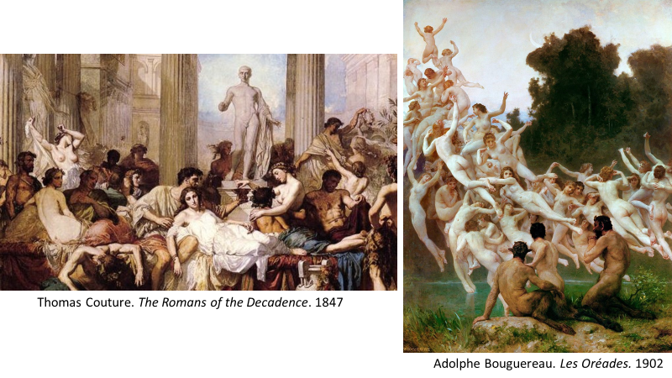 tradition, but, if nothing else, they tell us how strongly rooted it had become in Western consciousness. For some five hundred years, the purpose of art had been to create a harmonious, imaginary world – a world conventionally designated by the term “beauty” – and the word “art” in post-Renaissance Europe never had any other meaning. Manet’s Olympia and the art it inspired by painters such as Renoir, Cézanne, Van Gogh and Picasso was not just painting in a different style; it was painting of a fundamentally different kind, as this juxtaposition of a Poussin and a Cézanne indicates. Painting and sculpture of this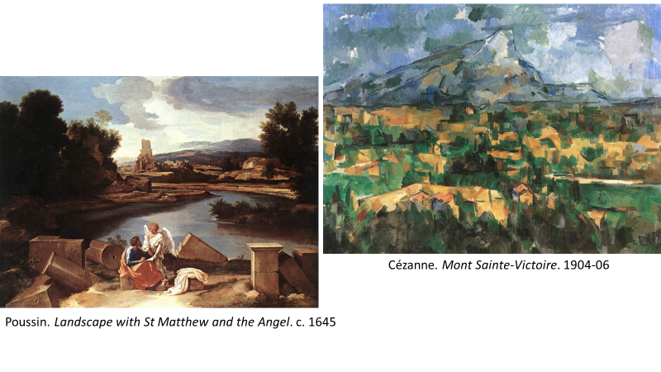 different kind is still called art because the term has been hallowed by centuries of usage and there is no other term available. But the impulse at the heart of this art has ceased to have any resemblance to the impulse at the heart of the art born with the Renaissance. Manet brought about a true artistic revolution whose consequences are still very much with us.
Let us, however, return to the post-Renaissance world which is my principal concern. As I’ve mentioned, the notion of art as beauty, with attendant ideas such as taste and aesthetic pleasure, was fundamental to the various forms of philosophical aesthetics that emerged in the eighteenth century. And, after all, what else would we have expected? The idea of art-as-beauty was, by this time, deeply entrenched in European culture, and if Enlightenment philosophers were to explain what art was, that idea would naturally be at the forefront of their thinking. Unsurprisingly, therefore, we encounter it again and again in writers such as Shaftesbury, Francis Hutcheson, Hume, Diderot, and Kant, Kant claiming, for example, in his well-known argument, that the distinctive pleasure underlying what he called judgments of taste is a harmony of the imagination and understanding elicited by the experience of beauty. And although nineteenth-century aesthetics found other fish to fry – especially the notion that art was intimately linked to historical change – it too fully endorsed the traditional association of art with beauty, Hegel for example claiming that Ancient Greek sculpture, which was then often seen as the archetype of great art, presents what he calls pure or “absolute” beauty. None of this is in any way surprising. Whatever philosophers today might like to tell themselves, philosophy is not always impervious to the cultural contexts from which it emerges, and since the notion of art-as-beauty was an unchallenged principle in the eighteenth century and most of the nineteenth, one would hardly expect philosophical accounts of art devised during those periods to be based on anything else. The works of Tintoretto, Poussin, Rubens and so many others were art, and art – Michelangelo’s 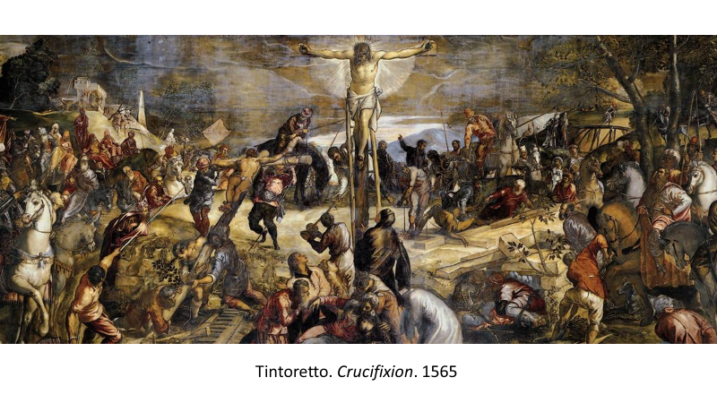“beauteous art” and Sidney’s “golden world” – could not conceivably be anything else. This was not one school of thought among others: it was reality itself – the way things really were, and only a fool or an ignoramus could think otherwise.
All that, as I say, is quite understandable. What is less so, however, is why the notion of art-as-beauty is still alive and well among many philosophers of art today – some 150 years after Manet when so much of our modern world of art no longer bears any resemblance to a “harmonious imaginary world”. Modern aesthetics, I should interpose here, is a far less coherent body of thought than it was in the eighteenth century. Different intellectual forces are pulling it in different directions and as one recent writer, a leading figure in Anglo-American analytic aesthetics, puts it, philosophical aesthetics,
is literally disintegrating [and] what seem to be emerging are semi-autonomous intellectual domains, with their own questions, methods, and reference points, at best only loosely gathered under the heading of aesthetics, at worst barely recognizable as aesthetics at all.
Despite this, however, it remains the case that the influence of the eighteenth-century founding fathers, if I may so term them, is still very strong today, and much of the academic discourse among modern philosophers of art continues to be framed around ideas derived from Kant, Hume and their contemporaries. Certain adjustments have been made, of course, and the idea of beauty, for example, is now typically described in rather abstract, disembodied ways, with little obvious connection with the post-Renaissance tradition to which it belongs. At heart, nonetheless, modern philosophical aesthetics continues to see itself as the child of Enlightenment forebears and standardly looks to writers such as Hume and Kant as its seminal thinkers, if not its ultimate authorities. All of which, to my mind, is decidedly odd and regrettable. In effect, large areas of modern aesthetics are behaving as if nothing fundamental has happened in the world of art over the last hundred and fifty years, and as if the art-as-beauty era had never come to an end. Not that philosophers of art today avoid talking about modern and contemporary art; indeed, this is often their preferred hunting ground, largely I suspect, because it drastically foreshortens the historical perspective and allows them to overlook the kinds of major historical developments I’ve considered in this paper. But whatever the cause, the outcome is clear. Whether the subject is modern art, the art of earlier periods, or even of other cultures, the default position for many modern philosophers of art is still some version of the aesthetics of the eighteenth century, even if, on occasion, re-interpreted in unusual ways.
Does this matter? That depends on what one thinks the philosophy of art is for. If it is nothing more than the elucidation of the thinking of previous philosophers, perhaps it wouldn’t matter much. But few philosophers of art would limit it to this and I certainly wouldn’t. A key purpose of the philosophy of art, to my mind, is to provide people – not just philosophers but anyone with an interest in art – with intellectual tools that will help them understand our world of art. I’m not thinking of intellectual tools that will necessarily help understand particular works; that’s often the province of art criticism. I’m thinking, rather, of ideas that provide a framework – an appropriate gateway if you like – to the world of art we now know, a gateway that fosters a receptive state of mind, or at least avoids fostering the opposite. Now, any suggestion that the works I’m showing you now fit readily into a
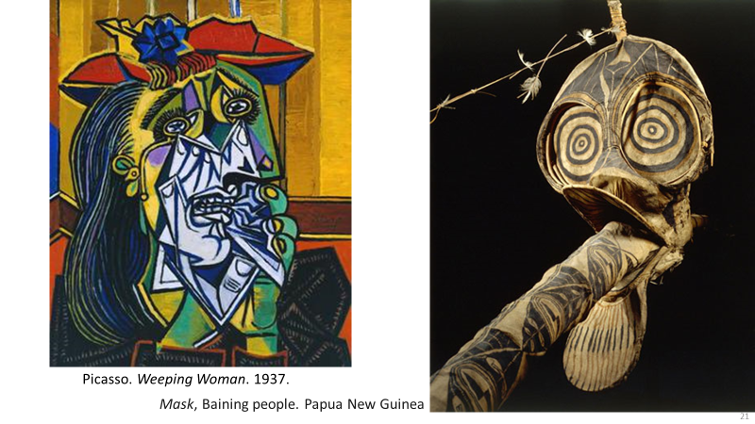framework in which art is understood as a world of harmony and beauty would, in my view, be very dubious, if not absurd. And if, as often happens, someone tries to overcome this problem by defining beauty in such an abstract and disembodied way that it even seems to cover cases like this, the problem doesn’t go away; it has simply been smothered in vagueness and obscurity. I’m not suggesting, I should stress, that works such as these should be described as ugly. In an effort – a desperate effort, I think – to make Kantian aesthetics relevant to works of this kind, certain contemporary philosophers of art have argued that when Kant writes about beauty, he also means its opposite – ugliness – a claim that, to my mind, stretches credulity to breaking point, especially when one bears in mind the cultural context in which Kant wrote. In any event, the two works we are looking at now– one from Europe, one from the Pacific Islands – are not adequately described as ugly; if they were, we would simply want to turn away. In reality, I would argue, they exert a kind of fascination and they are powerful works of art not because they are beautiful or ugly but because they derive their power from sources that have nothing to do with those traditional categories. This is what I meant earlier when I said that, today, the idea of art-as-beauty tends to sow confusion and place a barrier between us and the world of art as we now know it. That eighteenth-century explanation encourages us to look for qualities in art that are often simply not there and were never intended to be there; and as a result, we are simply left puzzled and frustrated. Of course, we still respond to works in the art-as-beauty tradition. Indeed, that tradition has given us many of the masterpieces of Western art. But we no longer see them as the post-Renaissance world saw them; we have incorporated them into a wider world of art in which we can place them beside works of very different cultures, and willingly call them all “art” – something that Hume or Kant would have found quite incomprehensible. 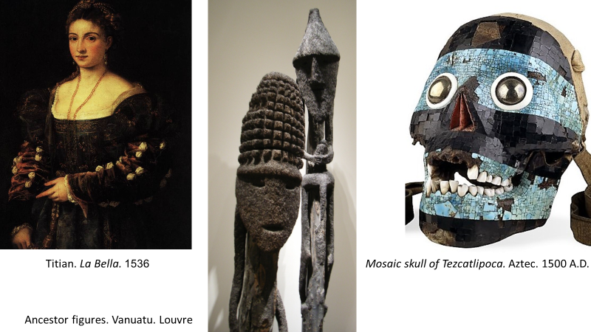

This is not, of course, a generalised attack on eighteenth century philosophy. Nor is it an attempt to argue that what Kant and Hume and their contemporaries wrote about art was somehow nonsensical. But it is an attack on the relevance of Enlightenment thinking about art to the world we live in today. The tradition to which that thinking refers – the tradition of art-as-beauty – has died: the life has gone out of it as surely as the life has gone out of the creative forces behind ancient Greek sculpture, or the works of ancient Egypt or Buddhist India. Today, we continue to use the word “art”, hallowed by centuries of cultural prestige in the West, but the meaning of the term has changed radically. We might still, of course, wish to describe a particular work of art as beautiful, just as we might describe it as powerful or fascinating or disturbing or moving; but the tradition of art-as-beauty – the tradition whose last major exponents were Delacroix and Turner – has died, and the forms of philosophical aesthetics based on that tradition need now to die as well.
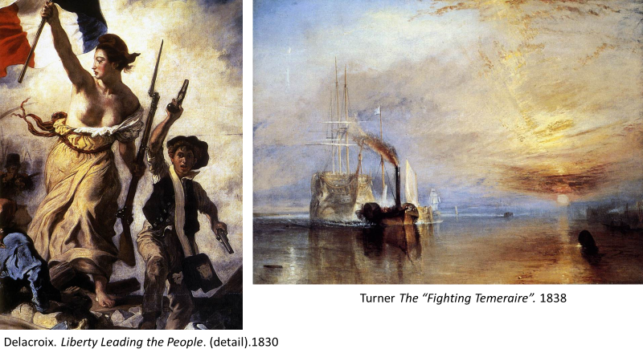
I’d like to finish on a more positive note. In addition to the idea that art is beauty, the eighteenth century also claimed that the purpose – the raison d’être – of art was to elicit a certain form of pleasure, often termed aesthetic pleasure, and like the idea that art is beauty, this claim also lingers on in modern aesthetics. The precise nature of “aesthetic pleasure” has been described in many different ways and you’ll forgive me if I don’t enter into those sometimes arcane debates. But I do wish to suggest that the proposition that art exists simply to elicit a form of pleasure, no matter how defined, is a trivialisation. One can understand why it may have seemed appropriate in the eighteenth century when, towards the tail end of the art-as-beauty era, cultural values were heavily influenced by notions such as refinement, sophistication, taste, grace, elegance, and gratification – as the images I’m now showing suggest (see next page). And once again, one can understand how the thinking of philosophers of the times might have been influenced by these cultural values.
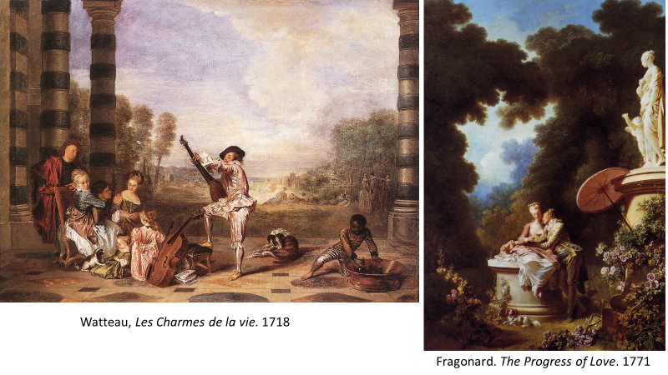
But we only need place paintings such as these beside something very different such as the mediaeval Christ in Majesty at Moissac we saw earlier, to see how limited and incongruous the idea of pleasure can often be when applied to art. We will never know precisely what ideas and feelings were in the mind of the sculptor of the work on the left, or what the reactions were of those for whom it was sculpted. But we can safely assume that the sculptor’s motives were religious in nature and that this severe and imposing work was not intended simply to elicit some form of aesthetic delectation. And the same can be said of large numbers of works that now make up our modern world of art from cultures as various 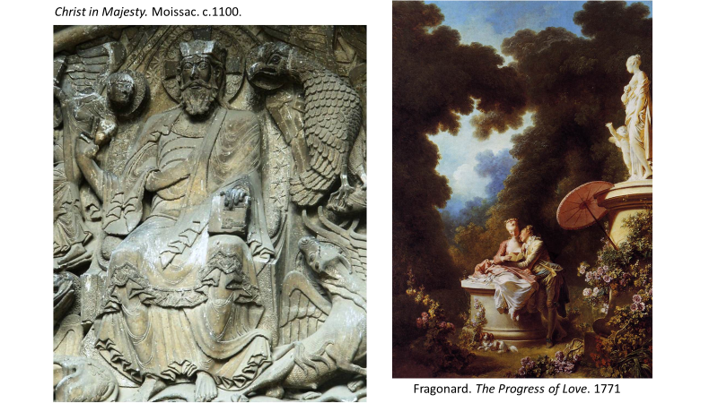as ancient Egypt and Mesopotamia, Pre-Columbian Mexico, India and Africa. Malraux once wrote: “How easy it is to imagine a history of art in which the Renaissance would be only an ephemeral humanist accident!” By which he meant that the vast majority of works that go to make up our world of art today were originally religious in nature and that, seen in this light, the Renaissance seems rather like a brief humanist interlude.
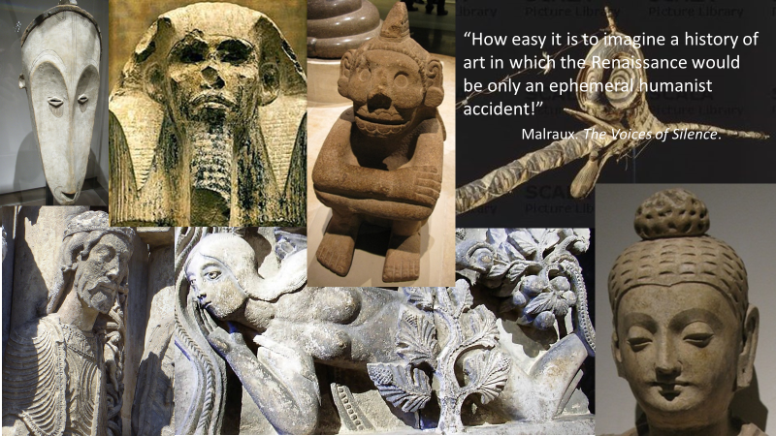

I don’t wish to be misunderstood. I’m not suggesting that art should be religious, or that art is a religion, or that only religious art is authentic. But I am asking whether the fundamental questions to which art responds are far deeper than questions about pleasure and may even be the same as those to which religions have responded – whether we’re speaking of religious art or not. It’s much too late in my paper to enter into this subject in any depth – although I have done so elsewhere. But at the risk of sounding hopelessly enigmatic I would like to say a little more: What art and religion have in common, it seems to me, is an attempt to humanise the world in a very broad sense of that term – that is, to resist the fundamental sense of transience and mute indifference that seems to lie at the heart of the universe in which we live, and to combat the inevitable feelings of human insignificance this elicits in us. The difference between art and religion, I would argue, is that religions have always sought definitive solutions to this dilemma, while art only offers a series of provisional answers. That aside, however, both seem to me to address the same fundamental enigma – the underlying incomprehensibility of things, and our sense at certain moments that human existence is nothing more than blind fatality, or as Macbeth lamented, “a tale told by an idiot full of sound and fury signifying nothing”. Once we see matters in this light, we begin, I think, to see the deeper significance of the human phenomenon we call art. Like religion, if in a different way, art is essentially an expression of the fundamental human impulse to call this incomprehensible scheme of things into question – to combat the sense of subjection to blind fatality that seems to lie at its heart, and replace that with a world charged with human meaning. Throughout the ages, this impulse has found expression in many different ways. For thousands of years, and in a wide range of cultures, it
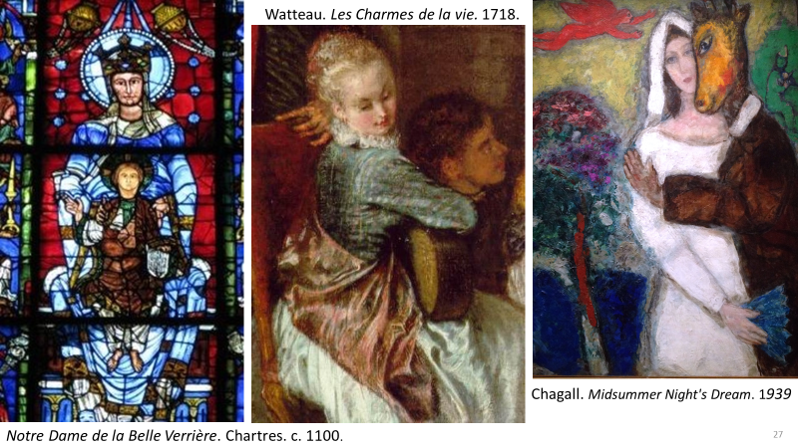found expression in religious works – long before the word art was even invented. In Europe from the Renaissance onwards, it found expression in works that sought to create a certain kind of transfigured, beauteous world – the world that first gave birth to the term “art”. In our own times, inaugurated by Manet, it has found expression in works that fall back on the artist’s basic capacity to create another world, renouncing any value beyond that. And – who knows? – the future may perhaps see another transformation as basic and as unexpected as that triggered by Manet’s Olympia. The essential point is that, powerful and highly influential though it was, the close relationship between art and beauty that began with the Renaissance is not a permanent, essential feature of art, despite the tendency of many modern philosophers of art to suggest the contrary. André Malraux once wrote that the fundamental impulse at the heart of art is to “deny our nothingness” – a formula he would, I believe, have applied to religions as well, despite the important differences between the two. In Western art, for several centuries, this denial of our nothingness took the form of an ardent pursuit of a world of harmony and beauty, a pursuit that has left a deep impression on Western culture. That era however, has now passed. It has bequeathed us many of the glories of Western art – in literature, visual art and music – but we can see now that it was only one episode in the adventure of art and by no means a final chapter.

Sonnet XVII
Peter Lamarque “The Disintegration of Aesthetics”

